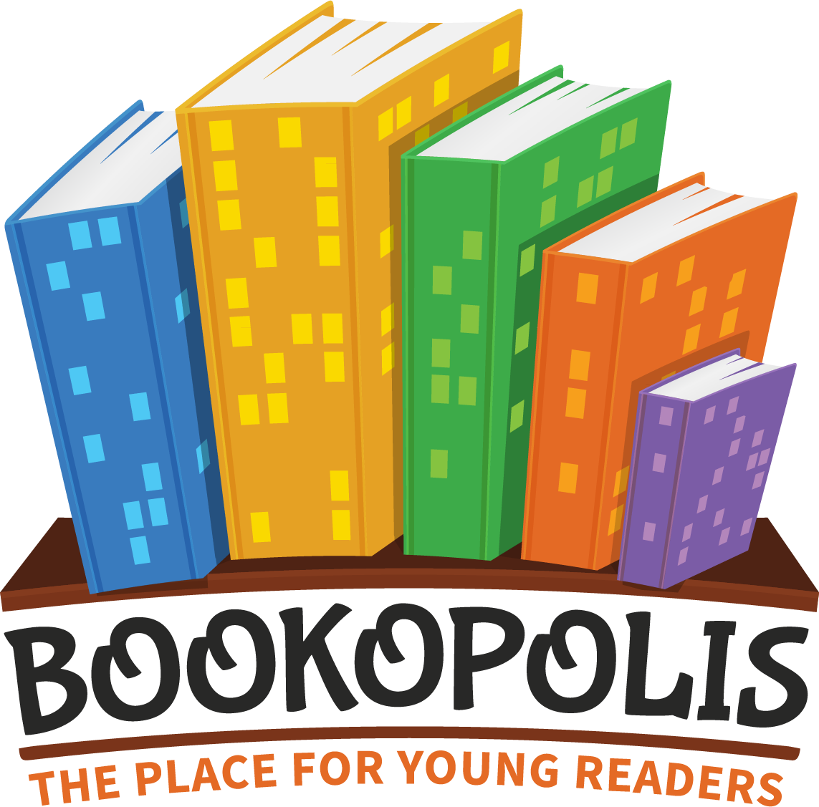
INFORMATION FOR FAMILIES

Dear Families,
Building a love of reading is one of our top priorities this year. Research shows that making independent reading more social and helping students find books that they are excited to read are two important ways to engage our students as readers.
In class, we are using Bookopolis.com, an online community for young readers, that helps ignite a love of reading by letting students connect with friends to share their favorite books. In Bookopolis, students can:
*Create virtual bookshelves of books they’ve read, are reading, or want to read
*Rate and review books to practice opinion writing
*Complete book reports to practice comprehension and critical thinking
*Track daily or weekly reading in an online reading log
*Connect with friends to see what books they’ve read
*Explore new book ideas and reviews from curated lists and other readers
*Earn points and badges for their reading achievements
Your student already has a Bookopolis account that is connected to my teacher email. Students can log in to their account from any computer or tablet. All of the students in our class are connected as “Friends” on the site so they can see each other’s bookshelves and book reviews.
If you want to have a Parent account, provide me your email and you will receive an invite from Bookopolis to create your own account connected to your student’s account.
If your student wants to connect with friends outside of our class, they can use the “invite a friend” feature and you will receive an email asking for approval for each invited friend.
Bookopolis is a free site that is compliant with COPPA (child online safety standards.) The creator is a book club facilitator and parent, Kari Riedel. Email her directly with any questions or suggestions you have about the site – kari@bookopolis.com.

Student Username __________________________ Password __________________________

